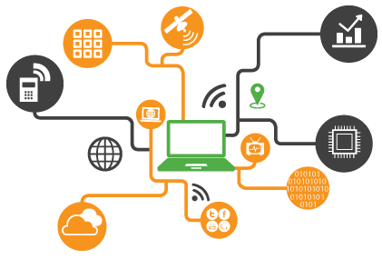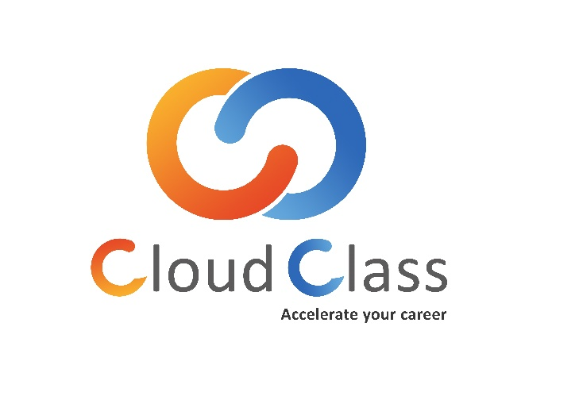

Internet of Things (IoT)

# About Cloud Class

We are a group of Linux (open source), Microsoft, Python, Cloud Computing & IOT Professionals with together having decade of experiences, and on the path of creating an impressive track record of consistently delivering value to our corporate clients. We aim to become a seamless extension of our client’s organization and a valued partner in the success of their business, not just another solution provider.

# What We Do?

We strive to provide service to customers with emphasis on continuous improvement, courtesy, timely response and accuracy with a goal of achieving customer satisfaction CLOUD CLASS is a best-in-class learning solutions organization headquartered in India’s IT capital, Bangalore. We offer a wide range of courses in the area of software and IT. A “finishing school” in many ways, the institute provides young job aspirants the perfect launch-pad to build a rewarding career in the growing IT sector.

# What you get?

We provide Trainers, who are Professionally Certified & Industry Recognized Cloud Architects. Internals/External Exams at the end of each topics/course to help you gain experience and practice.

* Classroom, Online & Corporate Training.
* In-Depth Practical Knowledge on each Topic.
* Implementation of Live project based scenarios.
* Professionally certified & experienced trainers.

Contents

About Cloud Class 1

What We Do? 1

What you get? 1

The Best of IoT training 4

Pre-requisites 4

Workshop Outcomes 4

Course Content 5

Introduction 5

IoT Architecture 5

IoT device design & management 5

Arduino Programming fundamentals (HANDS ON) 6

Interfacing Sensors and Actuators (HANDS ON) 6

Introduction to Communication protocol for IoT 6

IoT Communication Channels 6

MQTT IOT Protocol (HANDS ON) 6

Cloud Computing 7

IoT Platform (Hands On) 7

Demonstration of iot real time projects 7

**Introduction**

IoT is the most hyped, emerging field at present from industrial machines to wearable devices - using built-in sensors to gather data and take action on that data across a network. There is an explosion of IoT start-up companies; IoT devices introduced in the market is increasing; IoT offerings are on the rise. It is expected that IoT technology will touch all the application areas and will soon become part of our everyday life.

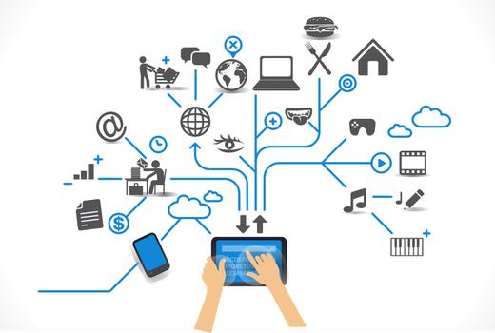

It is estimated that more than 25 billion IoT devices will be connected by the year 2020. As per IDC forecast, worldwide market for IoT solutions will be around $7.1 Trillion in 2020. This is a huge market and for India to get sizeable share of this market needs to plan now. Skill development is one of the key aspects of this planning. The reality is that the IoT allows for virtually endless opportunities and connections to take place, many of which we can't even think of or fully understand the impact of today. The purpose of this document is to identify the broad skills required for IoT market and syllabus required to train the resources. The Best of IoT training

# The Best of IoT training

The IoT training curriculum has been prepared after factoring in actual business problem that students/professionals can get to solve in the real world once they have passed the course. Training is delivered by the vast experience industry experts, with more focus on hand on practical sessions.

* Our syllabus is professionally designed to cover basic as well as Advance aspects of IoT
* Each day of our training is well planned to provide you with theoretical as well as Practical Knowledge of the module
* Each day will come up with new practical & projects, which makes the workshop interesting and exciting.
* Time to time practical assignments provided to the students/professionals, which will help them in doing practice at home.
* Revision Time & Query Sessions is provided to the students/professionals, which help them in clearing previous doubts.
* Time for Project Workshop provided to the students/professionals, in which students will develop a project of their own choice. This will encourage Innovative Ideas among students/professionals
* Online support will be provided

# Pre-requisites

Basics Computer Knowledge. Programming Knowledge on C / C++ / Embedded C would be beneficial however not mandatory since the basics will be covered as a part of training.

# Workshop Outcomes

* Learn the basics of Internet of Things and its applications.
* Business outcomes
* IoT components, devices, hardware, software requirements
* What “the Internet of Things” means and how it relates to Cloud computing concepts.
* The basic usage of the Arduino environment for creating your own embedded projects at low cost.
* How open platforms allow you to store your sensor data in the Cloud.
* How to send data to the Internet and talk to the Cloud.
* Importance of Big data and Data analytics in IoT.

# Course Content

## Introduction

* What is IoT?
* How IoT is applied in different domains?
* Use cases ranging from Smart Cities to IIoT
* How large is the IoT Market in different domains?

## IoT Architecture

* IoT Technology stack
* Sensors & Actuators
* Hardware Platforms
* Wireless Communication Protocols
* Network communication Protocols
* Cloud, its components and IoT
* Data Streaming in IoT
* Data Store and IoT
* Analytics & Visualization for IoT

## [IoT device design & management](https://www.collaberatact.com/online-training-courses/internet-of-things-certification/#collapse_3grvy0)

* Introduction to IoT Development Boards – Arduino, Raspberry Pi, Intel Galileo, ESP8266, NodeMcu ,Micropython.
* Sensors – Types, Classification & selection criteria
* Interfacing peripherals & Programming GPIOs – Input/output peripherals, Sensor modules
* IoT Hardware Platform & comparison
* Criteria for selecting Hardware platform
* Design Considerations – Cost, Performance, Scalability & Power Consumption tradeoffs

## Arduino Programming fundamentals (HANDS ON)

* How to program IoT Board with Arduino IDE
* How to make your IoT board respond to sensors and actuators
* Reading data from analog/Digital Sensors
* Writing data to analog (PWM)/Digital actuators

## Interfacing Sensors and Actuators (HANDS ON)

* Connecting sensors to IoT Board to read data from sensor and display on serial monitor (Temperature, Humidity, Distance, Light etc).
* Connecting actuator to IoT Board and controlling Actuator (LED, Buzzer, Relay, Push button, RGB Led, )
* Controlling a buzzer using Ultrasonic sensor.
* Demo project with sensor and actuators.

## Introduction to Communication protocol for IoT

## IoT Communication Channels

* Wi Fi, GSM/GPRS, 2G, 3G, LTE
* Comparison of Communication Channels
* How to select a Communication Channels based on Use Case

IoT Network Protocols

* MQTT/MQTTS, CoAP, 6LoWPAN, TCP, UDP, HTTP/s

Comparison of the Network protocols

* How to select a Network Protocol based on Use Case

## MQTT IOT Protocol (HANDS ON)

• Introduction to MQTT

* Why MQTT?
* Features of MQTT
* MQTT Subscribe/Publish
* MQTT Broker
* MQTT QoS
* MQTT Security

### Cloud Computing

* Concept & Architecture of Cloud
* Role of Cloud Computing in IoT
* Tools, API and Platform for integration of IoT devices with Cloud
* IoT cloud platform and integration with Gateway.
* Web services and APIs

### IoT Platform (Hands On)

* Read data from sensors,
* Create JSON Object
* Establish MQTT/CoAP/HTTP connection using Wi Fi
* Send JSON data to cloud Rest API over HTTP/MQTT
* Create business rules in cloud for alarms
* Create rule and configure Alarm(SMS/Email) for your device
* Send data to cloud which will trigger the alarm
* Create and configure Chart/Graph/ for visualization
* Control the actuator from cloud using polling technique
* Home automation using google home assistant

## Demonstration of iot real time projects

* IoT Home Automation
* IoT Environmental Monitoring
* Google Home Assistance
* IoT based Water monitoring and Distribution.

**IoT Starter KIT Includes:** IoT Development board, Sensors, Actuators, Buzzers, LED's, RGB module, Bread board, jumpers resisters, switches.

**Training Duration:** Two days.

**Who is the Target Audience:**

* Students of ECE/CSE/EEE/ME/IP/Civil/MCA/Diploma Engineering / Masters/Research Scholar/PhD's.